|  |  |  |  |
| --- | --- | --- | --- |
| Signal’s Name | From | To | Comment |
| Instruction (8 downto 6) | Instruction memory | Rmux2 | SRFW2 = 0 |
| Instruction (5 downto 3) | Instruction memory | Rmux2 | SRFW2 = 1 |
| Rmux2_to_Rmux1 | Rmux2 | Rmux1 | SRFW1 = 0 |
| Rmux1_to_WREG | Rmux1 | WREG signal in Register file | If SRFW1 = 1 => ‘111’  RW = 1 |
| ALU_Result | ALU | DATA mem and Rmux3 | SRFD3 = 0 |
| D_to_DATA_in_RF | DATA mem | Rmux3 | SRFD3 = 1 |
| Rmux3_to_Rmux4 | Rmux3 | Rmux4 | SRFD2 = 0 |
| Program_Counter_Inc | ADDER1 | Rmux4 , PCmux3 , ADDER2 | SRFD2 = 1  PCmux3 = 0 |
| Rmux4_to_Rmux5 | Rmux4 | Rmux5 | SRFD1 = 0 |
| InPort_to_DATA_in_RF | InPort | Rmux5 | SRFD1 = 1 |
| Rmux5_to_DATA_in_RF | Rmux5 | DATA_in signal in Register file | Check comp names and arch in this file |
| Instruction (5 downto 0) | Instruction memory | Sign extend |  |
| SE_Result | Sign extend | ALUmux1 , ADDER2 | SALU = 1 |
| R2 | R2 register file out2 | ALUmux1 , DATAmem input | SALU = 0 |
| ALU_B | ALUmux1 | ALU_B |  |
| R1 | R1 register file out 1 | ALU_A, PCmux1 , Outport | SPC1 = 1  DW = 1 , LOP = 1 |
| Instruction (11 downto 9) | Instruction mem | RREG1 register file in 1 |  |
| Instruction (8 downto 6) | Instruction mem | RREG2 register file in 2 |  |
| Instruction (2 downto 0) | Instruction mem | ALUmux2 | SALU1 = 0 , SALU0 = 0 |
| PCmux2_to_PCmux1 | PCmux2 | PCmux1 | SPC1 = 0 |
| Program_Counter_Input | PCmux1 | PC |  |
| PCmux3_to_PCmux2 | PCmux3 | PCmux2 | SPC2 = 1 |
| ADDER2_to_PCmux3 | ADDER2 | PCmux3 | SPC3 = 1 |
| Program_Counter_Output | PC | ADDER1 , instruction mem | Increment pc |
| Instruction (15 downto 12) | Instruction mem | CU | OPCODE |
| ZF | ALU | Two AND gates | Branch |
| AND1_to_OR | First AND gate | OR gate | ZF.BRCE |
| AND2_to_OR | Second AND gate | OR gata | BRCNE.NOT(ZF) |
| SIG_SPC3 | Branch circuit output | PCmux3 |  |
| Instruction (11 downto 0) | Instruction mem | PCmux2 |  |
| ALU_FUNC | ALU_MUX2 | ALU FUNC |  |

Instruction => دي السيجنال اللى طالعه من الانستراكشن ميمورى عالحجات الكتير اوى التانية دى

Program_Counter_Output(15 downto 12) & Instruction (11 downto 0) => دى السجنال اللى داخلة علي الماكس المسؤول عن الجامب اللى هو PCmux2

كل دول طبعا غير السجنالز اللى طالعة من الكنترول يونيت واللى اساميهم هى هى الاسامى اللى اسامة حاططها

الصورة اللى جاية دى هي الشكل النهائى بتاع البروسيسور وعليه اسامى الكومبوننت كلها بحيث تبقي فاهم ايه اللى انا كاتبه فوق ده

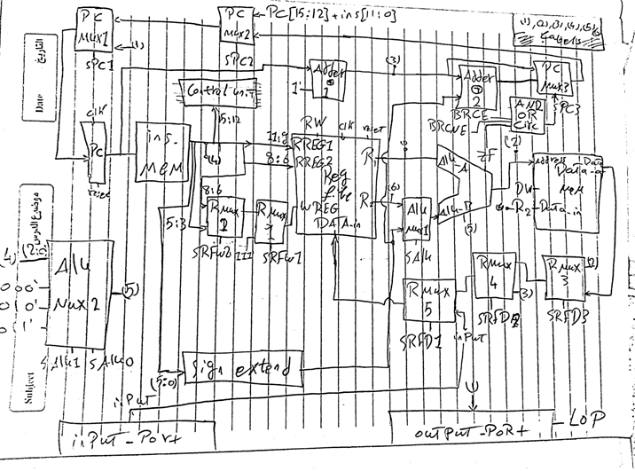

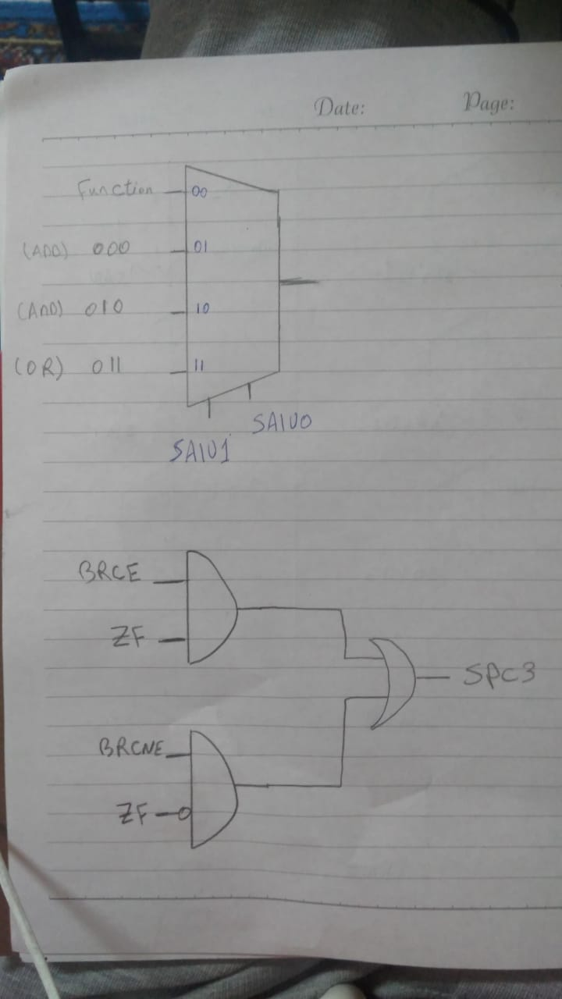

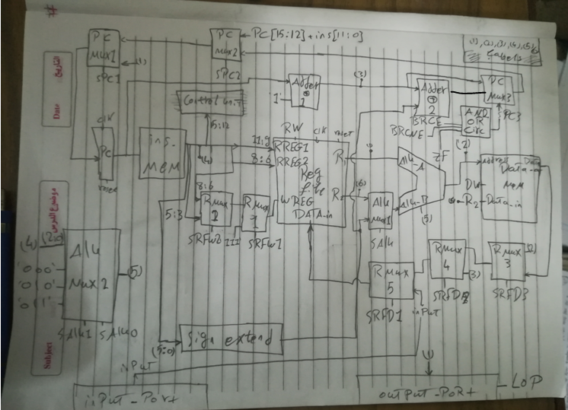

Instruction ,Rmux2_to_Rmux1 ,Rmux1_to_WREG ,ALU_Result ,D_to_DATA_in_RF ,Rmux3_to_Rmux4 ,Program_Counter_Inc ,Rmux4_to_Rmux5 ,InPort_to_DATA_in_RF ,Rmux5_to_DATA_in_RF ,SE_Result ,R2 ,ALU_B ,R1 ,PCmux2_to_PCmux1 ,Program_Counter_Input ,PCmux3_to_PCmux2 ,ADDER2_to_PCmux3 ,Program_Counter_Output ,ZF ,AND1_to_OR ,AND2_to_OR ,SIG_SPC3;